**Exercise 3: Online Bookstore - Handling Path Variables and Query Parameters**

Business Scenario:

Enhance the book management endpoints to handle dynamic URLs and query parameters.

1. **Path Variables:**

* I Implemented an endpoint to fetch a book by its ID using a path variable. This method will use the @PathVariable annotation to capture the ID from the URL.

1. **Query Parameters:**

* I implemented an endpoint to filter books based on query parameters like title and author. Used the @RequestParam annotation to handle these parameters.

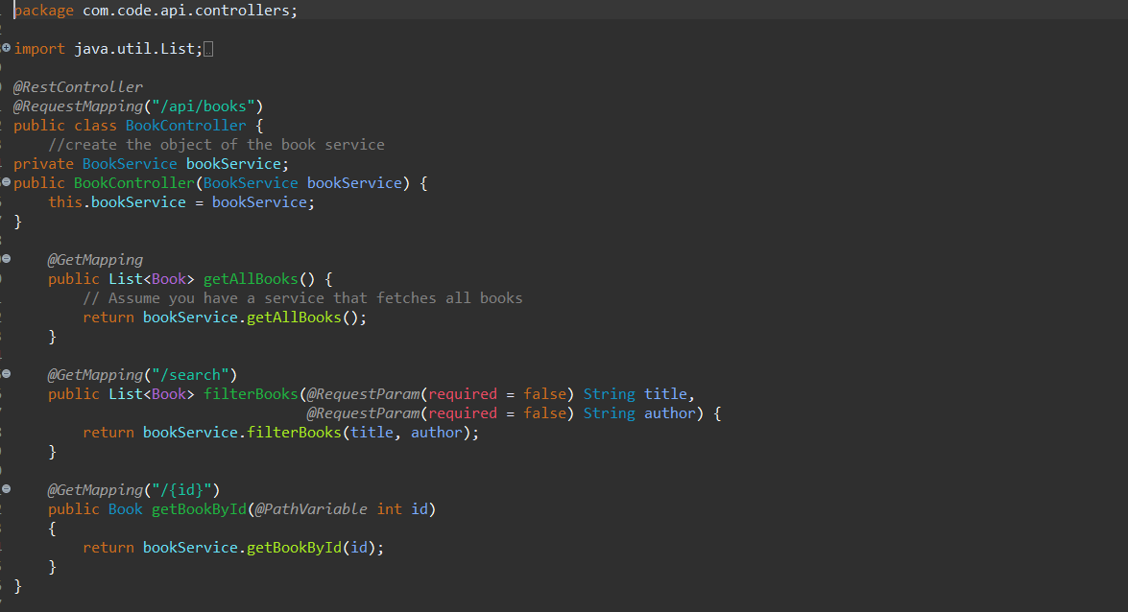

In the BookService class, I defined the methods to query the database based on the provided parameters.

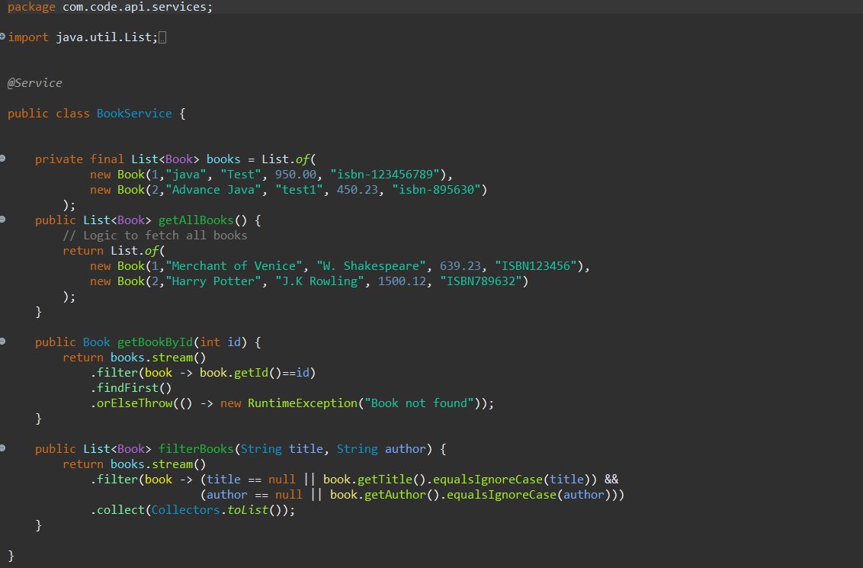

**Output:**

Fetching a book by its id:

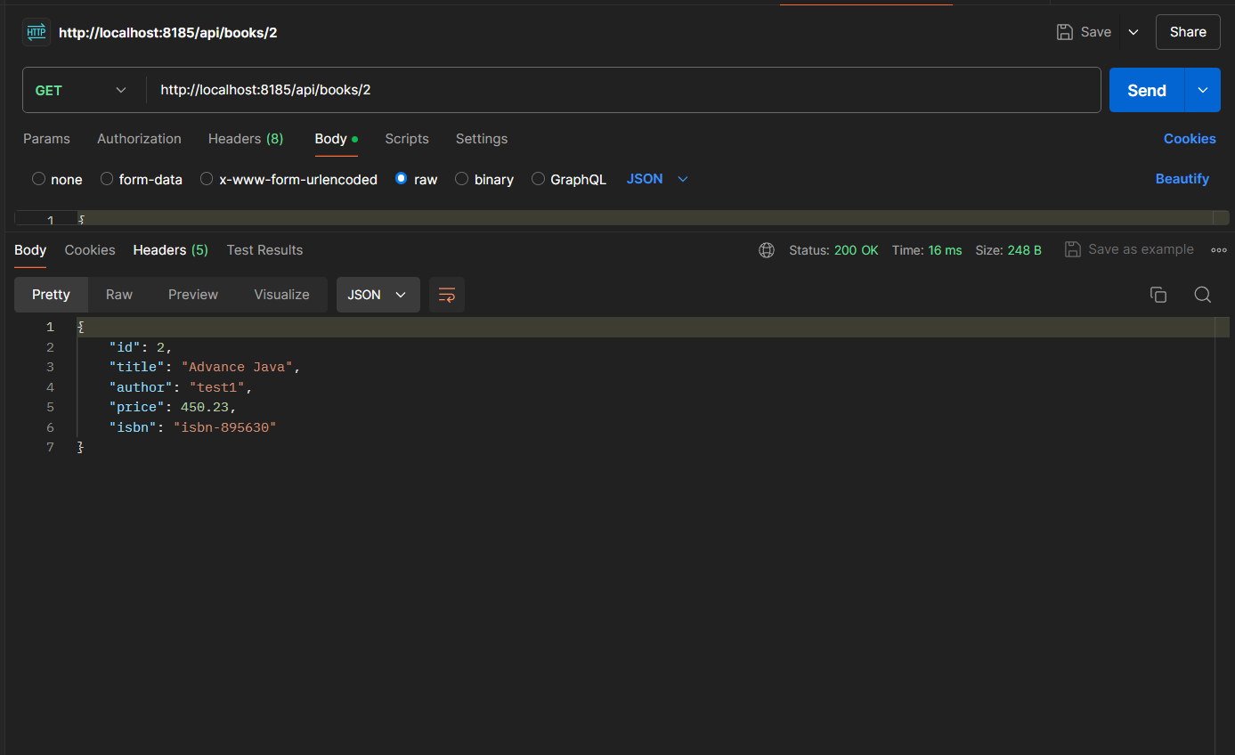

Search for Books with Query Parameter:

